**Power BI Assignment**

1. Firstly, Removing the duplicate data by using power query editor.

**Dashboard 1:**

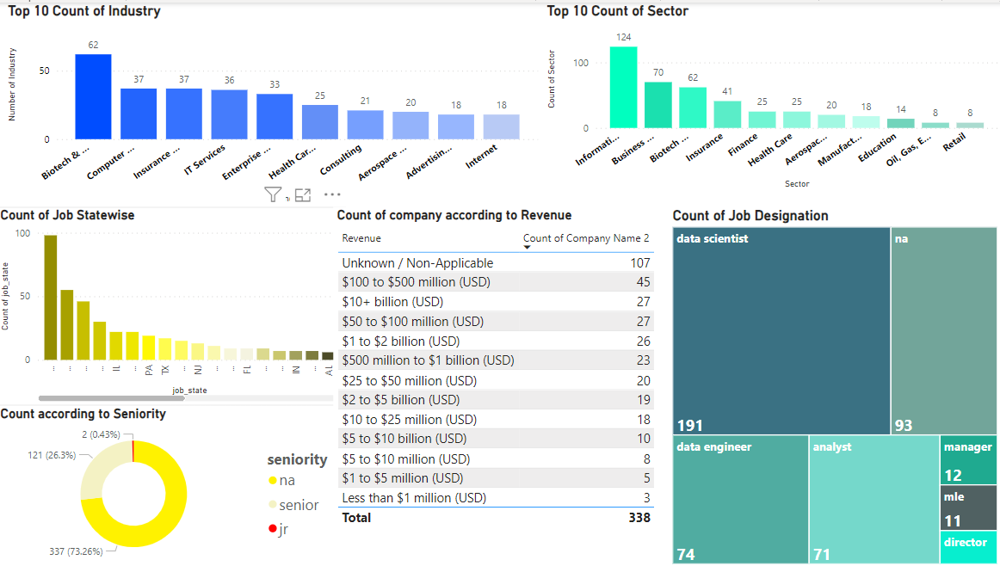

**Insights derived from charts:**

Chart 1: The bar chart shows the Top 10 industry in which maximum number of counts of data present of industry.

Chart 2: The bar chart shows the Top 10 sector in which maximum number of counts of data present of sector.

Chart 3: The bar chart shows the state wise total count of data.

Chart 4: The donut chart shows the count according to seniority level and it shows minimum count is of jr.

Chart 5: In this table it shows the data according to the revenue of the company and total number of counts of the company.

Chart 6: Tree map shows the number of counts according to the job_simp (job designation).

**Dashboard 2:**

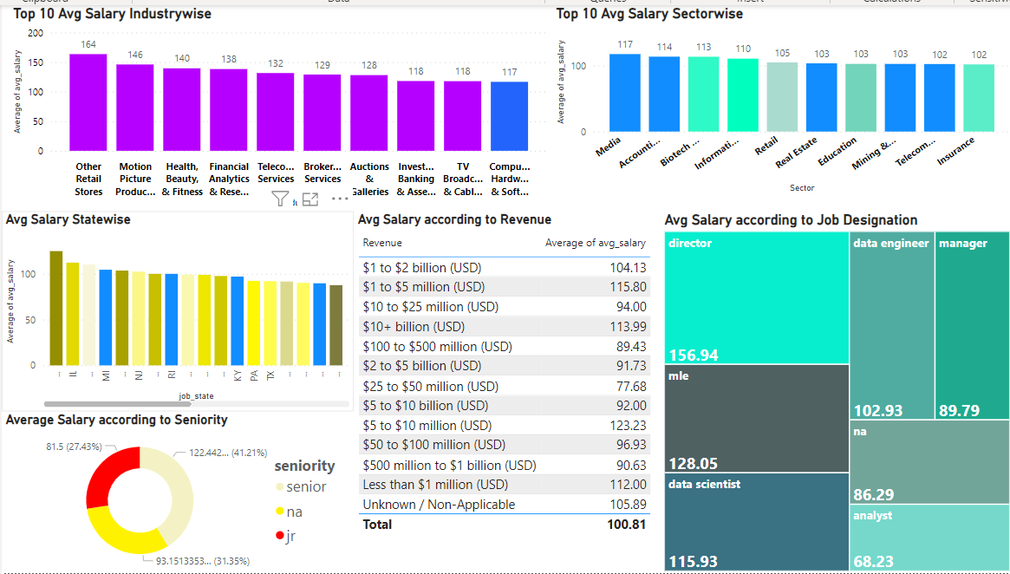

**Insights derived from charts:**

Chart 1: The bar chart shows the Top 10 maximum average salary of industry in which Other Retail Stores is having maximum average salary.

Chart 2: The bar chart shows the Top 10 maximum average salary according to sector wise.

Chart 3: The bar chart shows the average salary of state wise.

Chart 4: The donut chart shows the average salary according to seniority level and it shows maximum average salary is for senior.

Chart 5: In this table it shows the data according to the revenue of the company and average salary in which $5 to $10 million (USD) revenue companies having maximum average salary.

Chart 6: Tree map shows the number of average salaries according to the job_simp (job designation) and it shows director is having maximum average salary because they are in the higher designation of the company.